**Setting up Nexus Repo:**

1. After installing nexus in local .
2. Start nexus :

Docker: run container image

Downloaded folder : C:\Users\abhishesrivasta6\Downloads\nexus-3.49.0-02-win64\nexus-3.49.0-02\bin 🡪 cmd : nexus.exe /run

1. Sign in
2. Create user role:

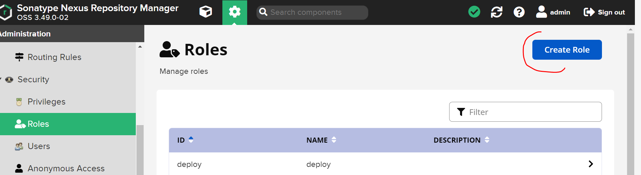

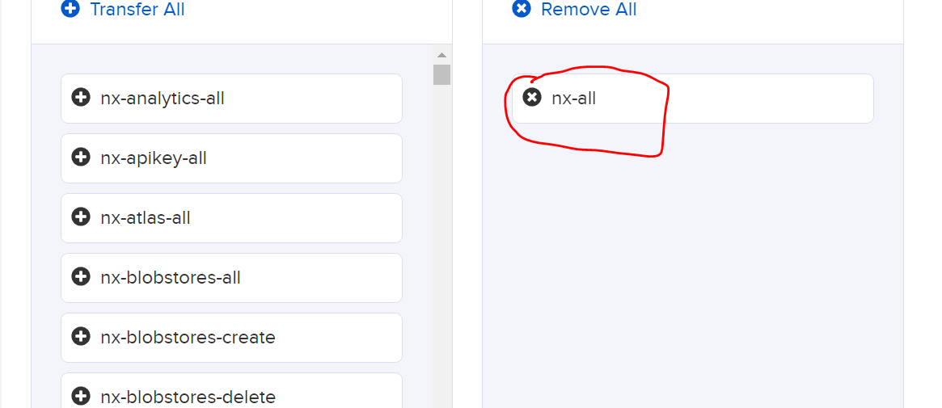

1. Add Role to admin user:

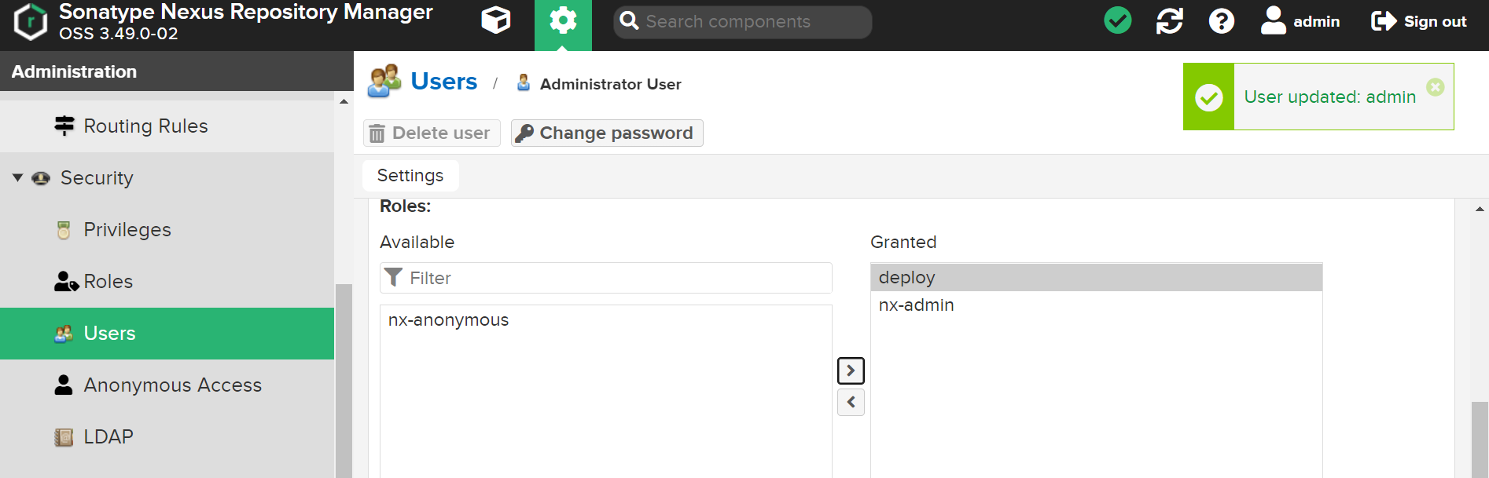

1. Create four repos as below with correct policy as hosted, group or proxy

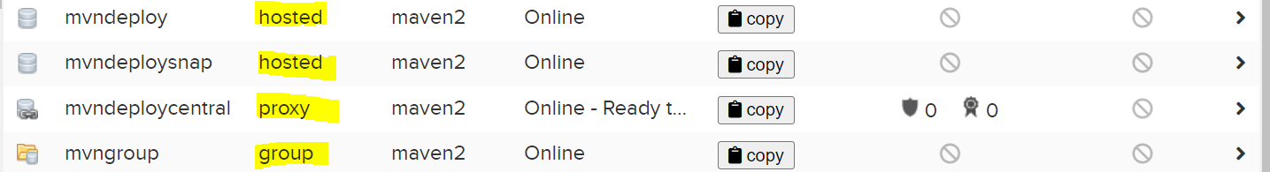

Mvndeploy: for release

mvndeploysnap: for snapshot

mvndeploycentral: for central repo

mvngroup: for having all repo artifacts

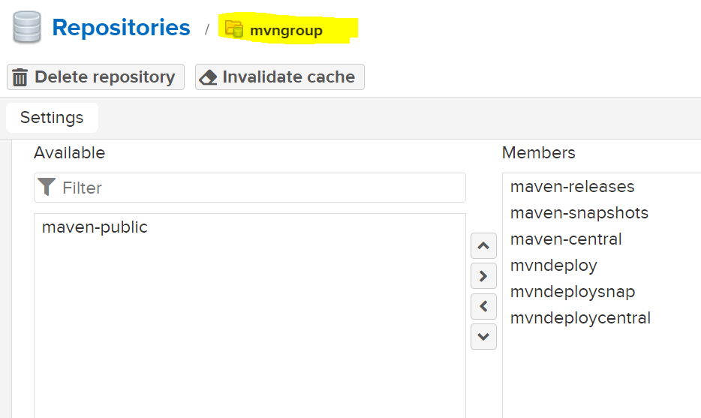

1. Add links of repos as shown in POM. (4th point of next section)

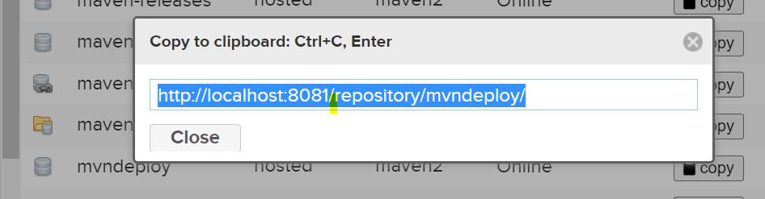

**After Setting up Maven :**

1. mvn archetype: generate
2. leave all fields empty except:

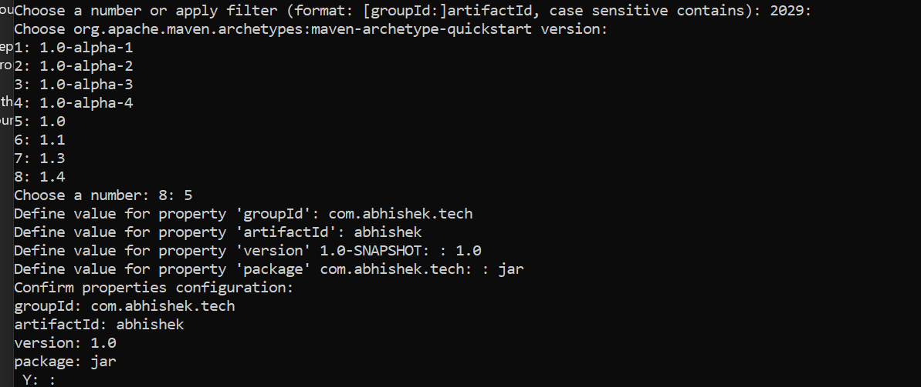

1. pom will be created
2. add

<distributionManagement>

<repository>

<id>abhishektraining</id>

<name>Internal Releases</name>

<url>http://localhost:8081/repository/mvndeploy/</url>

</repositor

<snapshotRepository>

<id>abhishektraining</id>

<name>Internal Releases</name>

<url>http://localhost:8081/repository/mvndeploysnap/</url>

</snapshotRepository>

</distributionManagement>

1. POM will be shown as:



1. Run mvn deploy
2. Add server tag in settings.xml as:

<server>

<id>abhishektraining</id>

<username>admin</username>

<password>{admin-password}</password>

</server>